## Project Report

**Name:** Nitin Bisht

UID: 23BCA10240

Section: BCA-4(A)

Subject: Desktop Publishing Lab



## Project Title

Making magazine on

**Project Title:** Creating magazine cover photos of Travelling.

Technologies Used: Adobe Photoshop Application

1. Abstract
2. Procedure
3. Project Objectives
4. Technologies Implemented
5. Project Features
6. Conclusion

Desktop Publishing Project -01

Making magazine on Weekend Traveler

# Introduction:

# "Weekend Traveler" is the go-to destination for people with a passion for short, unforgettable trips. Perfect for those who juggle a busy life but love to escape to new places on the weekends, Weekend Traveler is all about maximizing limited time. It provides travel guides, tips, and curated itineraries that make the most of those precious 48 hours, whether you're venturing to bustling cityscapes, quiet countryside getaways, or hidden local gems. With an emphasis on budget-friendly options, unique experiences, and time-saving hacks, Weekend Traveler inspires adventurers to explore without waiting for extended vacations.

# Objective:

Create **a Compelling Cover**: Develop a visually striking magazine cover that captures current trends and appeals to the target audience.

Enhance **Design Skills**: Gain proficiency in Adobe Photoshop, focusing on tools and techniques such as layering, typography, and image manipulation.

Communicate **Brand Identity**: Effectively convey the magazine’s brand through cohesive design elements that reflect its ethos and target demographic.

Engage **Readers**: Utilize headlines and design features that entice potential readers, encouraging them to explore the content within.

# Concept Used:

In designing the fashion trends magazine cover, several key concepts were essential. **Visual hierarchy** organized elements to guide the reader’s eye, emphasizing the magazine title and key headlines. **Color theory** informed the selection of a palette that reflects current trends and evokes emotional responses. The choice of **typography** involved stylish fonts that align with the brand while ensuring readability.

# Abstract:

This project involves designing a visually appealing cover for a fashion trends magazine using Adobe Photoshop. The objective is to create a striking and professional cover that reflects current fashion trends while showcasing the brand’s identity. The cover will include a bold title, engaging imagery, and enticing headlines that attract readers. Through this project, essential graphic design skills are developed, alongside an understanding of layout, color theory, and typography in the context of magazine design.

.

# Procedure:

Steps to Create a Professional Restaurant Banner in Adobe Photoshop:

* 1. Document **Setup**: Open Adobe Photoshop and create a new document with dimensions of 8.5” x 11” and a resolution of 300 DPI.
  2. Background **Selection**: Choose a high-resolution background image or color gradient, and apply it to the document.
  3. **Adding the Title**: Use the Text Tool to create the magazine title, selecting a stylish font and applying layer styles for emphasis.
  4. **Inserting Main Image**: Add a striking image of a model or fashion item, using layer masks to blend it seamlessly into the background.
  5. **Text Elements**: Incorporate headlines and subheadings using the Text Tool, ensuring they are well-aligned and visually appealing.
  6. **Decorative Elements**: Add shapes and icons to enhance the design, adjusting colors and effects as necessary.
  7. **Final Adjustments**: Review the overall layout for balance, making any necessary tweaks before saving.
  8. Saving **the Project**: Save the project as a PSD file for future edits

Images:

Step 1: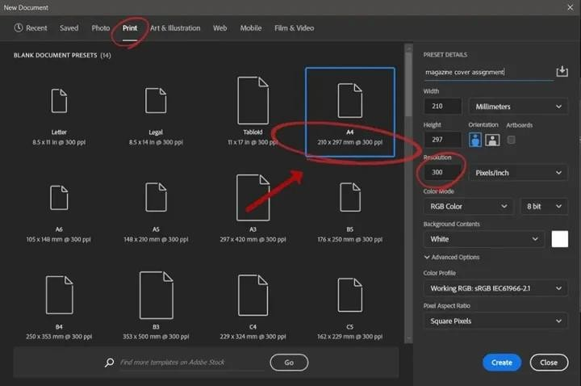

Step 2:

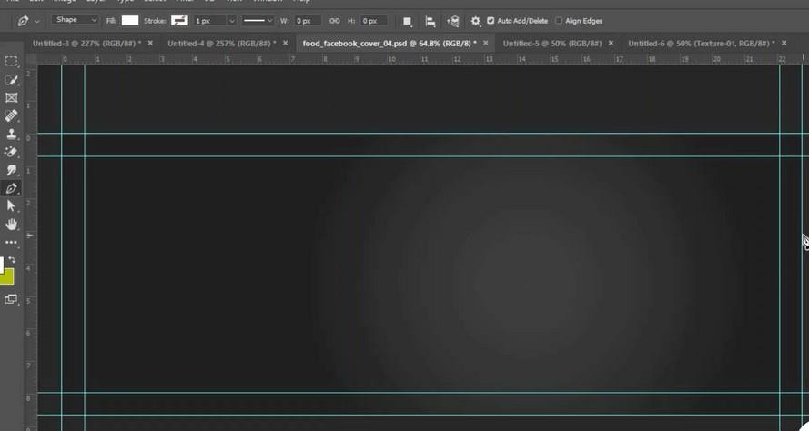

Step 3:

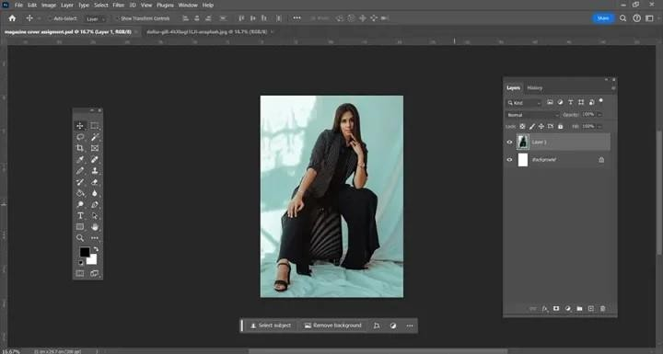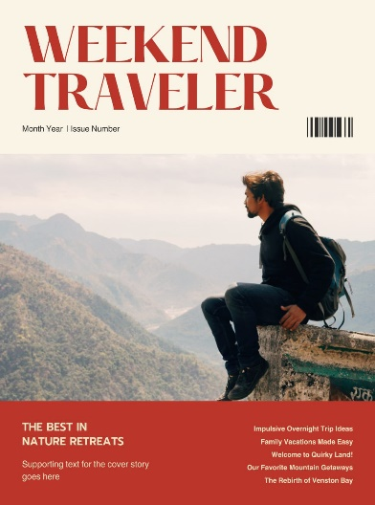

Step 4:

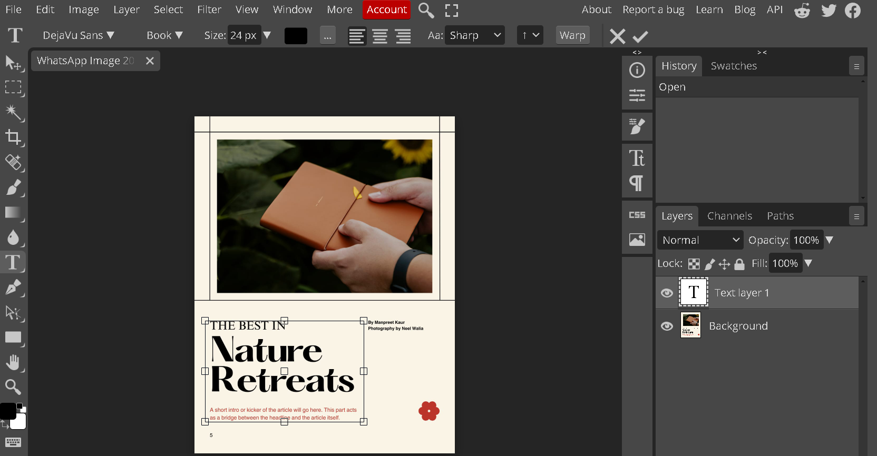

Step 5:

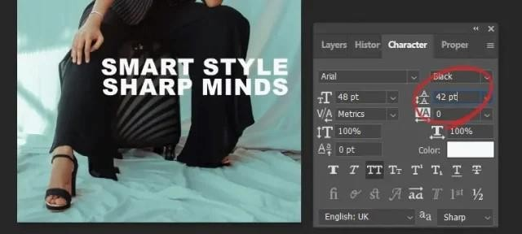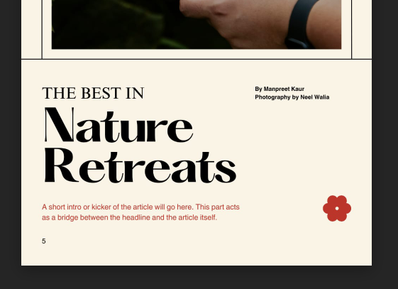

Final Output

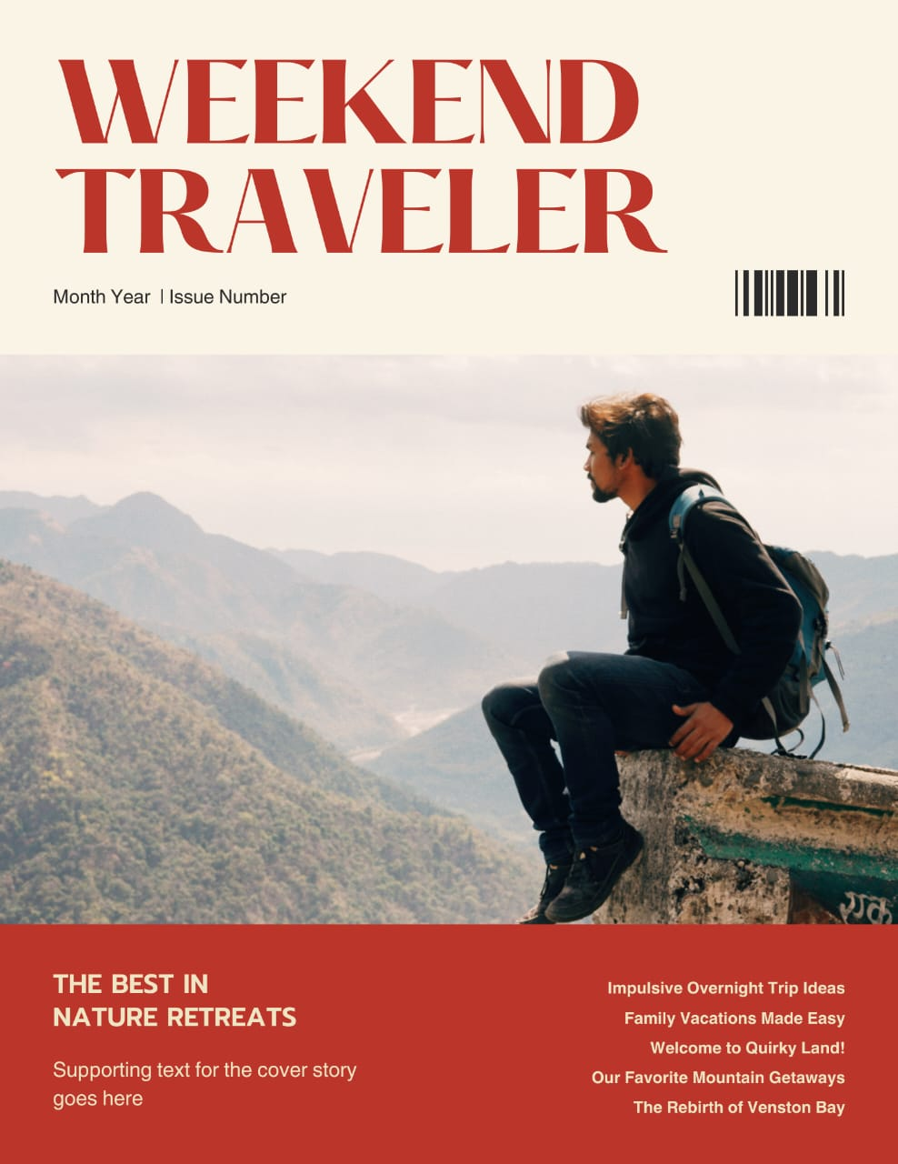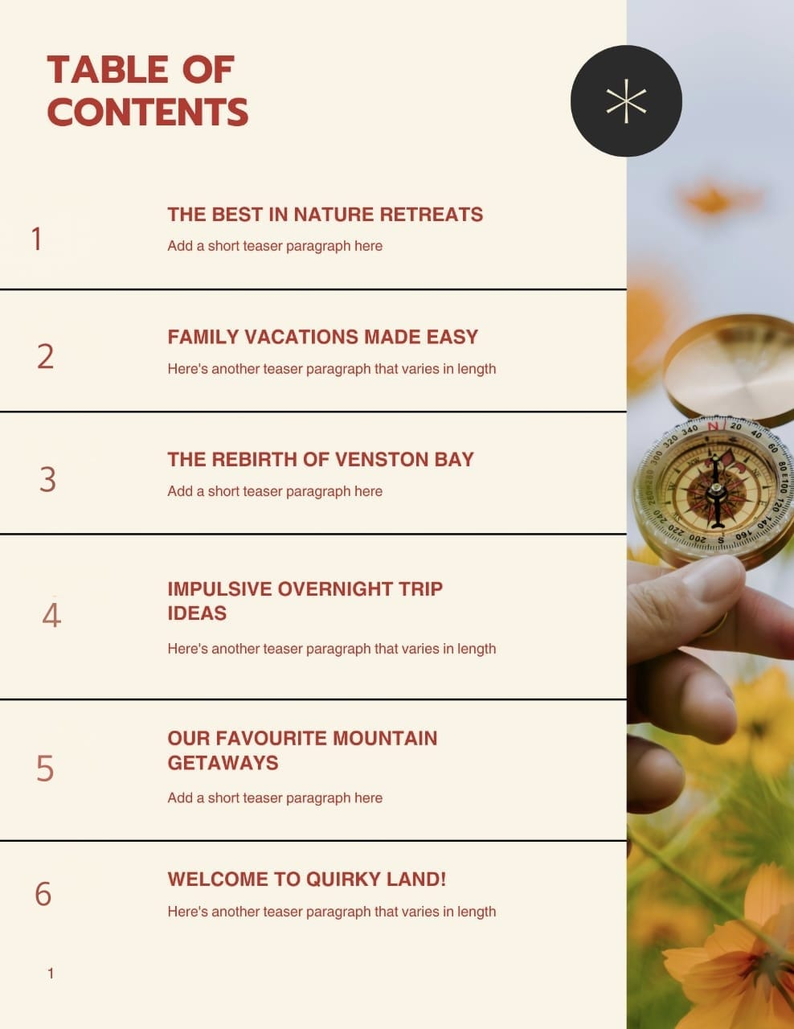

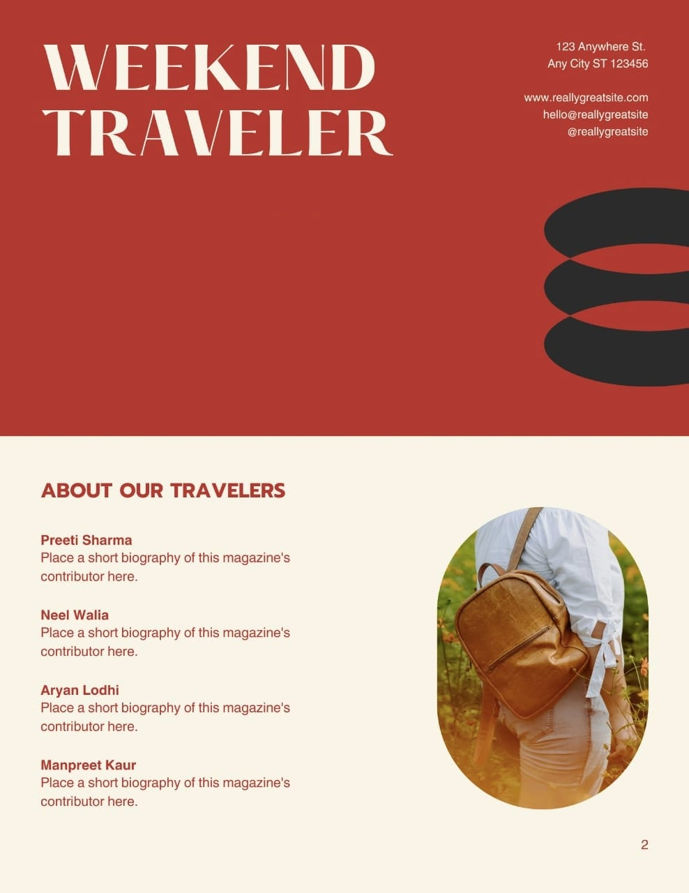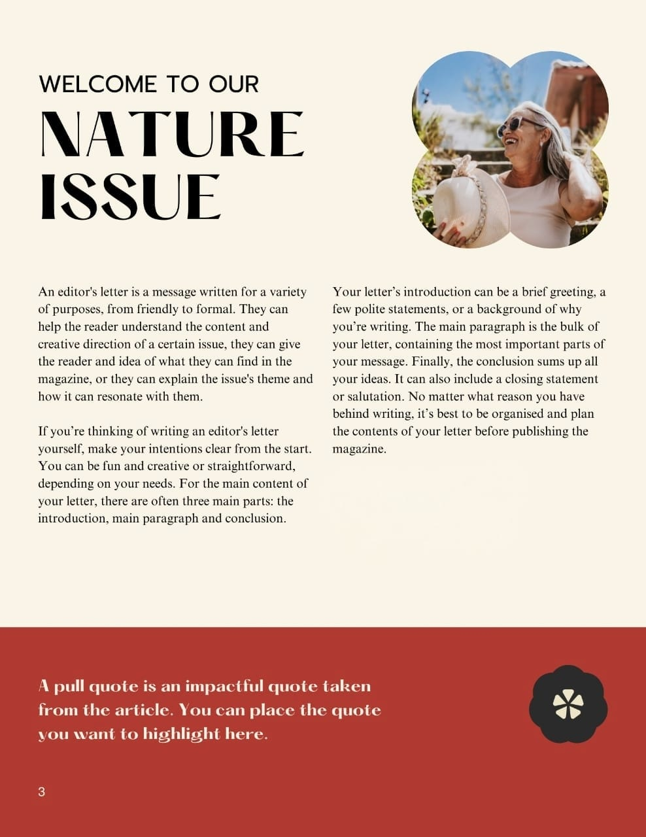

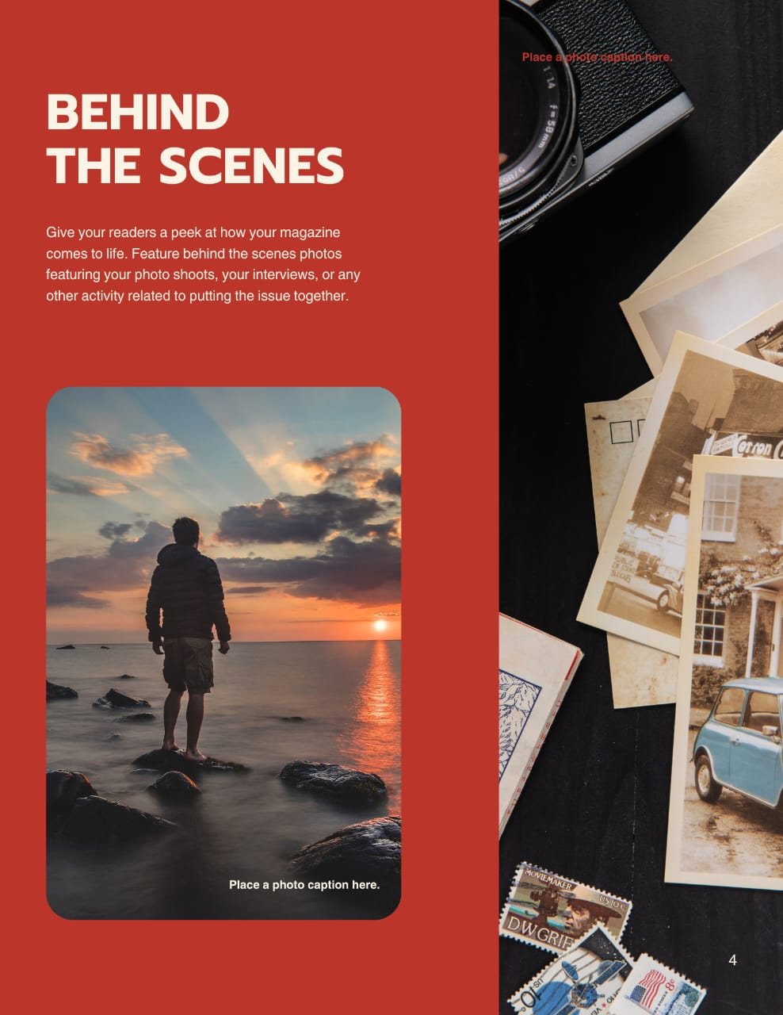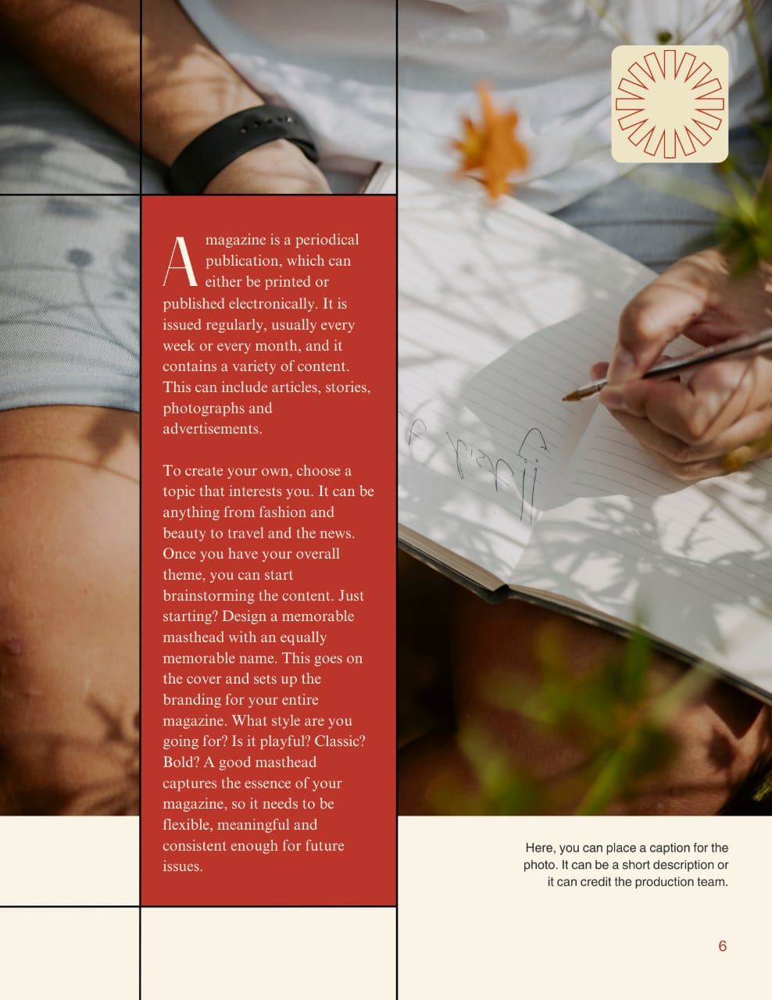

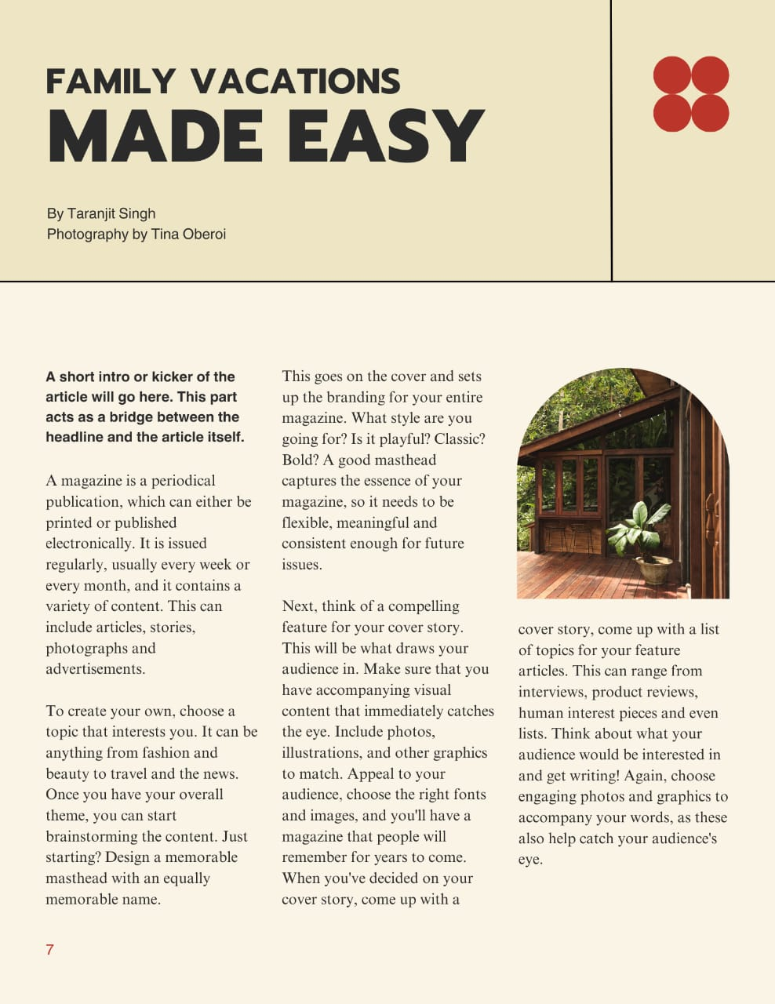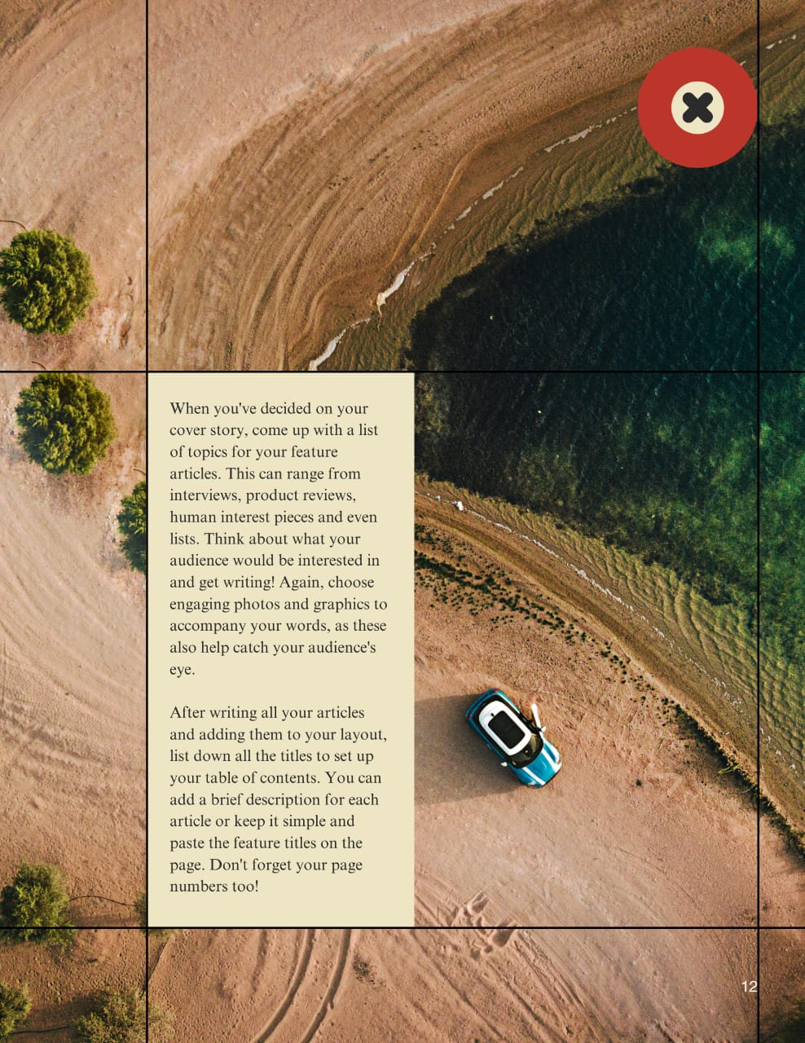

Project Objectives:

* To design magazine covers that attract attention and align with the brand's aesthetic.
* To highlight current vacation plans through a visually engaging cover.
* To develop skills in photo editing and graphic design using Adobe Photoshop

Conclusion:

The project successfully demonstrates the process of designing visually compelling magazine covers using Adobe Photoshop In a world where time is precious and everyday routines can feel all-consuming, *Weekend Traveler* offers a refreshing reminder: adventure is closer than you think. By embracing the philosophy of short, impactful getaways, it opens doors to new experiences, cultures, and connections—all without needing to wait for a long vacation. Whether you’re discovering a nearby town’s hidden gems, hiking through breathtaking landscapes, or indulging in local cuisine, *Weekend Traveler* makes each weekend an opportunity to rejuvenate and explore. So, pack your bag, set your out-of-office reply, and let *Weekend Traveler* guide you on your next unforgettable journey.